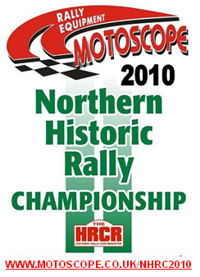
MOTOSCOPE Northern Historic Rally Championship 2010

REGISTRATION FORM

 | Driver | Co-driver
Surname

First Name

Address

Home telephone

Daytime telephone

E-mail address

HRCR Membership No.
(mandatory for both crew members)
Person to be contacted in the event of a serious accident
(Include phone no.)
Car make | Registration No. | c.c.
Model | Date first Reg. | Class entered: (see Appendix II)

I/We have received the Regulations for the MOTOSCOPE Northern Historic Rally Championship 2010 and undertake to comply with them and declare that the information provided in respect of this entry is true and that I/we are eligible to compete. The Vehicle entered will at all material times comply fully with the Championship Regulations and I/we understand a breach of the regulations, including that of vehicle eligibility may result in the imposition of penalties which could include exclusion from the Championship.

Signature ………………………………………………………. Driver
Date ……………………….

Signature ………………………………………………………. Co-driver
Date ……………………….

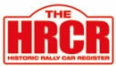

SEEDING AND PRESS INFORMATION

 | Driver | Co-driver
Name

Age

Occupation

How long competing in rallies

Interests outside Motor Sport

Local Media Details

Local TV & Radio Stations

Best Motor Sport Results

Car history and points of interest

This form should be returned fully completed on BOTH SIDES together with cheque payable to ‘HRCR Northern Historic Stage’ or cash for £20 (individual registration) or £35 (crew registration) to: Mark Casey-Championship Co-Ordinator, 32 Windsor Drive, Wigginton, York, YO32 2QQ

Registered competitors are entitled to a black polo shirt with the championship logo embroided onto it, please contact the championship co-ordinator and indicate what size you require.

Driver Navigator
S M L XL XXL S M L XL XXL

If you do not have access to email or the internet, please circle which crew member you would like championship points and updates posting to make sure you provide an address

Driver Navigator

